**Assignment 1**



**Table of Contents:**

Page 1: Title and logo

Page 2: Table of Contents

Page 3: Version history, Detailed Game Description, Controls, and Interface Sketch

Page 4: Screen Descriptions (Start State and Gameplay State)

Page 5: Screen Descriptions (Game-End State), Characters/Vehicles, Enemies, Scoring, and Sound Index

Page 6: Art / Multimedia Index (bullet image, grass image, tank mesh, bomb mesh, wrench mesh)

Page 7: All Assets Used

**Version History:**

Version 1 – October 25th 2015

**Detailed Game Description:**

Move forward as a hero dodging an enemy and collecting coins along the way, scoring points as you go along.

**Controls:**

WAD – up, left, right

**Interface Sketch:** 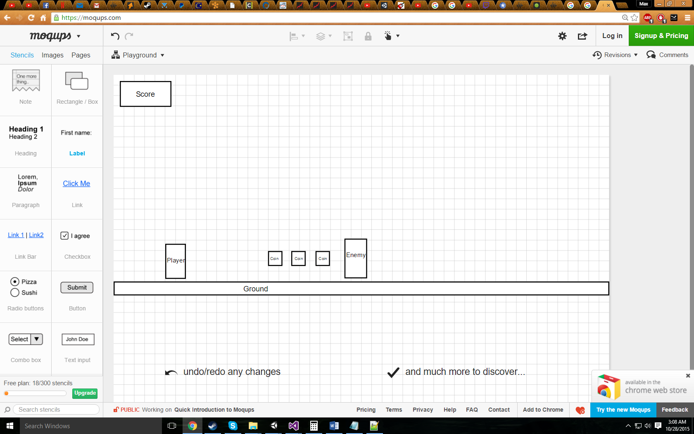

**Screen Descriptions:**

Start State:

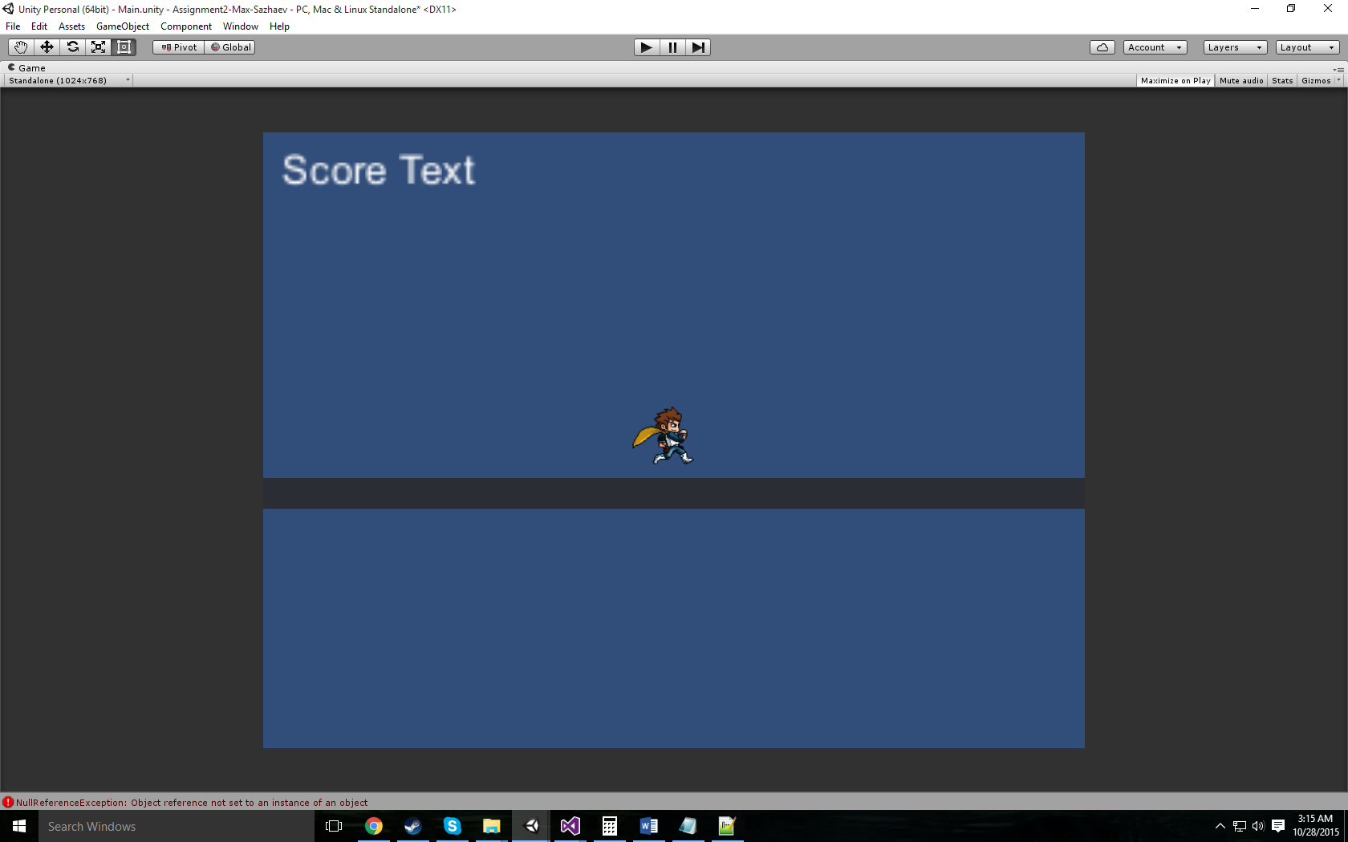

Gameplay State:

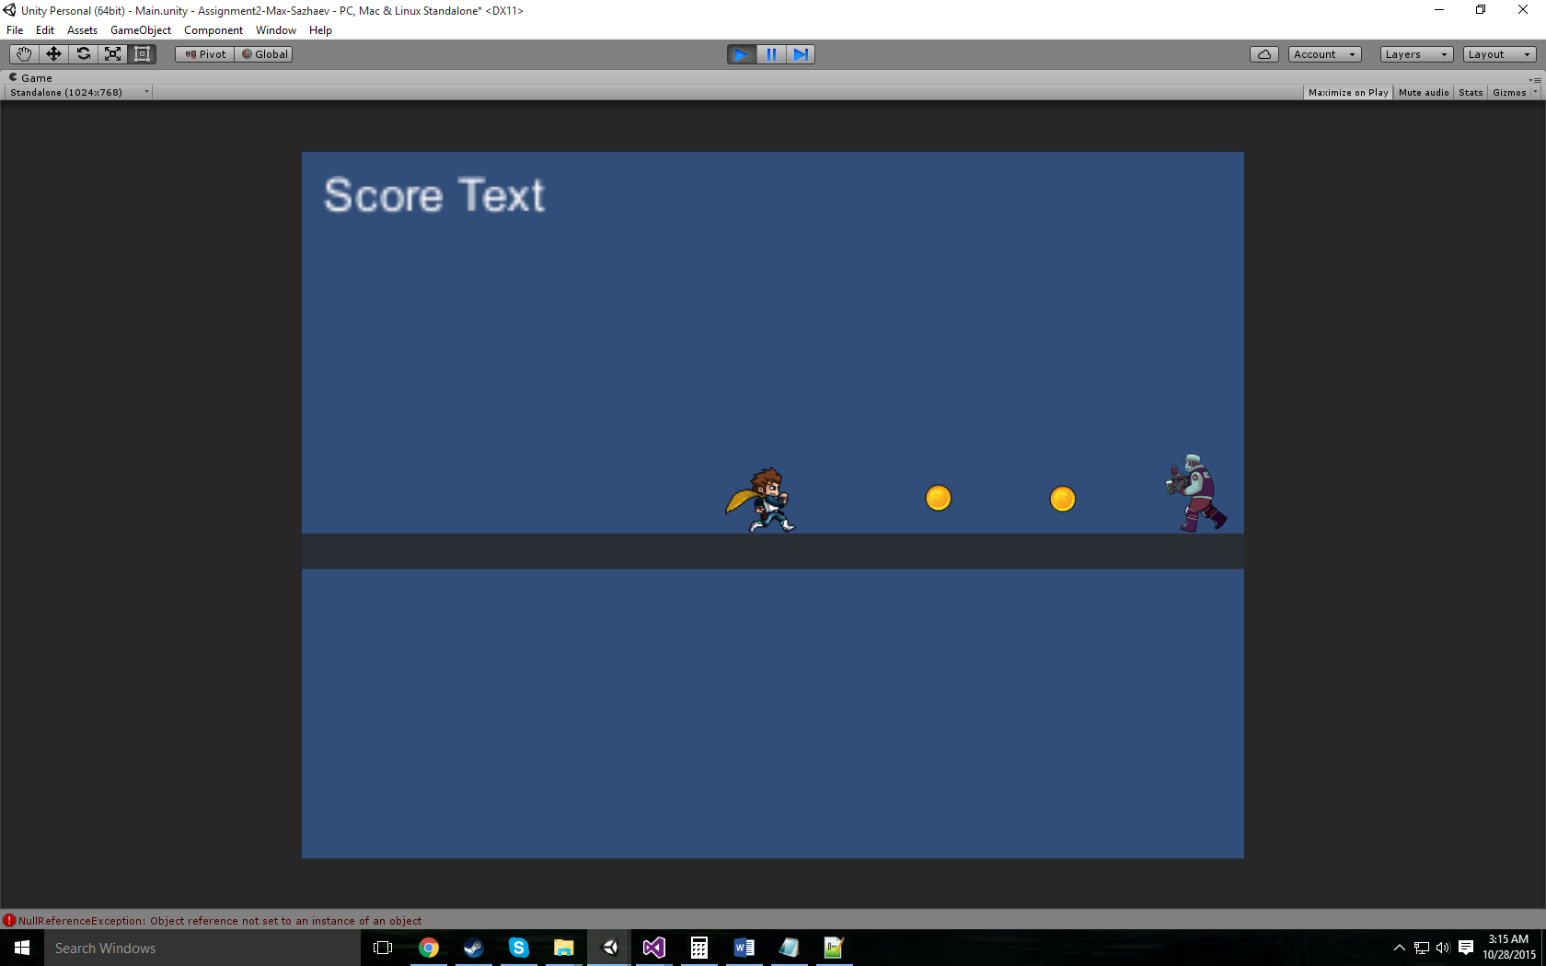

Game-End State:

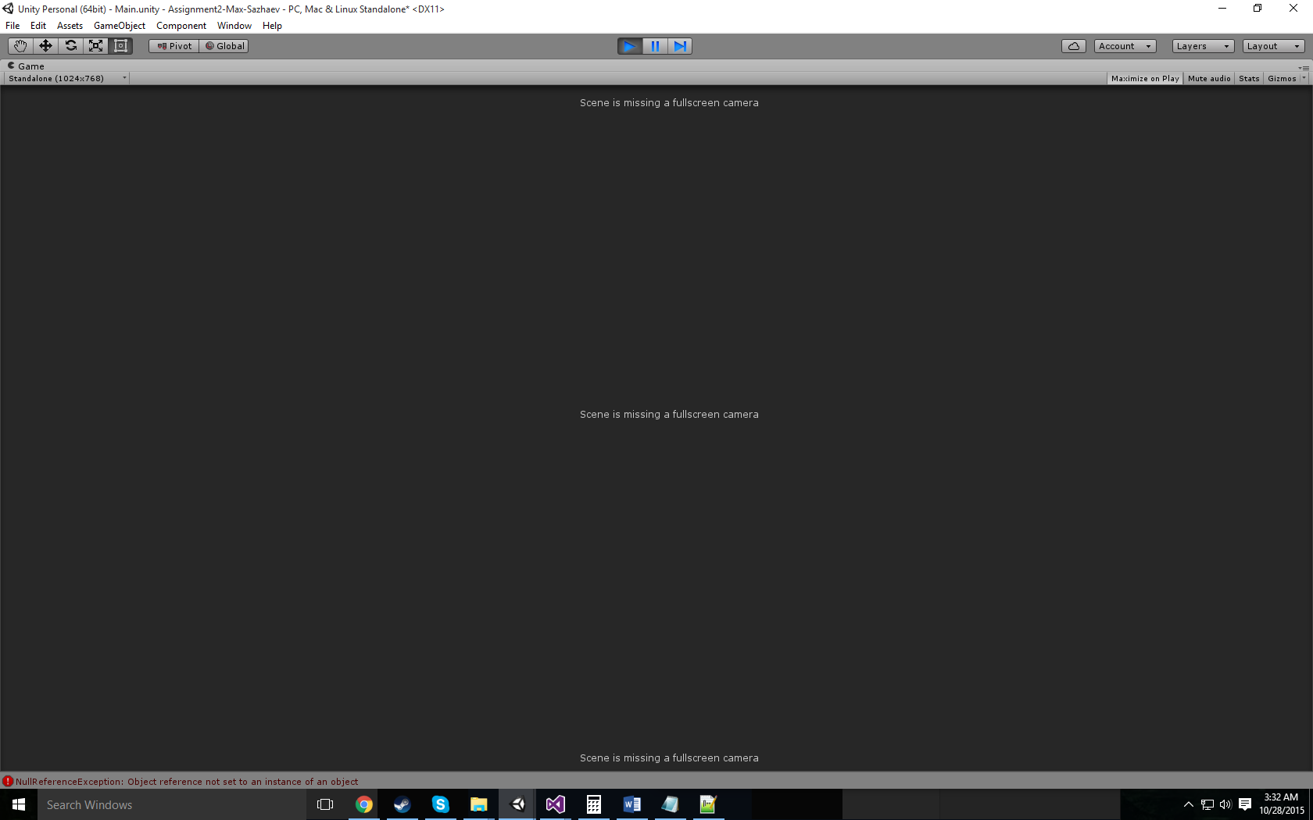

**Characters / Vehicles:**

Hero Player – moves right, left, and jumps

**Enemies:**

Enemy – constantly walking left towards the player.

**Scoring:**

100 points – Collect coin

**Sound Index:**

Coin Sound – Collect Coin

Death By Enemy Sound – Collide with enemy

Rock – Game soundtrack

**Art / Multimedia Index:**

Hero image:



Enemy image:

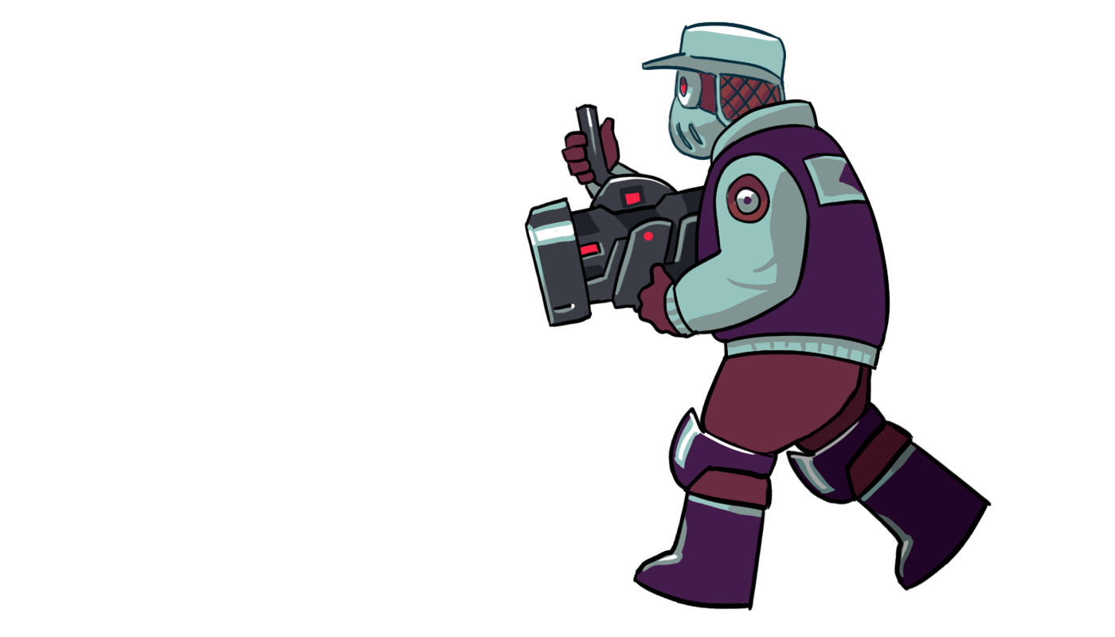

Coin image:



**All Assets Used:**

<http://icons.iconarchive.com/icons/hopstarter/soft-scraps/256/Coin-icon.png>

<https://freesound.org/people/thecluegeek/sounds/140584/>

<http://i.imgur.com/BiV6CT1.png>

<https://freesound.org/people/bradwesson/sounds/135936/>

<http://img10.deviantart.net/fa9e/i/2010/234/5/d/west_dash_animation_by_hero_in_pixels.png>